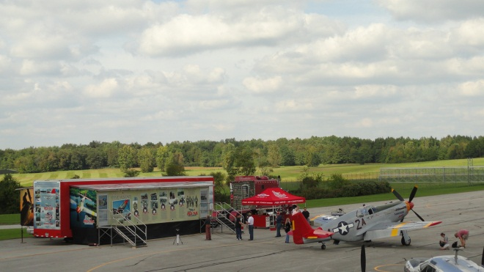

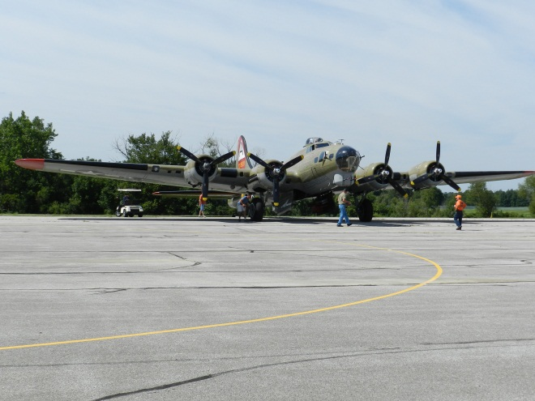

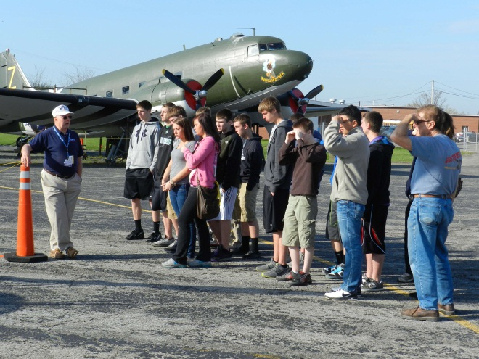

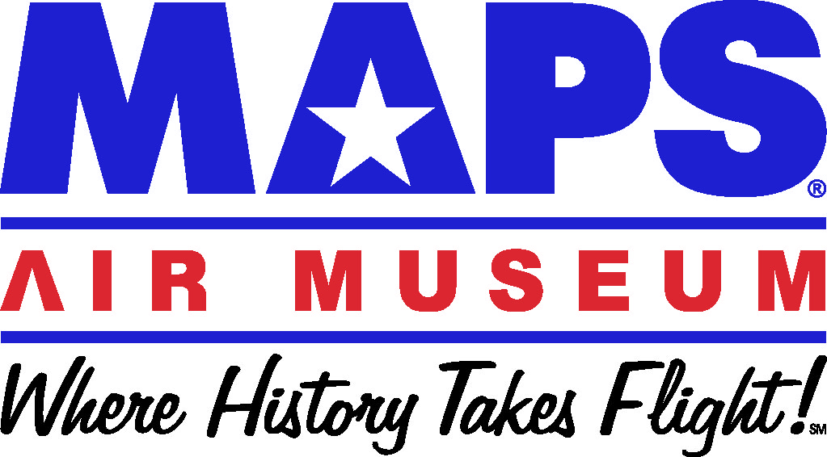

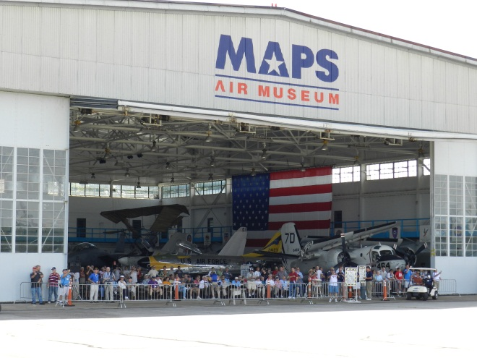

NEOEA DAY
OCTOBER 12, 2012
K-12 EDUCATOR’S SEMINAR

www.mapsairmuseum.org

2260 International Parkway, N. Canton, OH

Itinerary

7:30AM Breakfast & check-in
8:00AM Intro to MAPS
8:20AM Aviation in WWII
9:20AM Break
9:30AM Goodyear, Akron
& WWII’s Homefront
10:30AM Break
10:35AM Aviation & Economics
11:05AM Lunch
11:40AM Rotating Groups (20):
- Engines
- Restoration
- B-26 & Spirit of Akron Gondola
- Aeronautics (NASA)
- C-47 Walkthrough
1:10PM Break
1:15PM Mini Air Show
1:45PM Gallery of Heroes
2:15PM Door Prizes
2:30PM Depart
October 12, 2012

* Interact with real American heroes who made history!
* 1-3 hours of graduate credit available at a reduced cost for participation through the University of Akron’s Barker Center (Dr. Fred Carr).
* Discover how your students can enjoy a day of meaningful, thought-provoking, hands-on learning viaa MAPS field trip.
* K-12 lesson plan ideas and resources for all content areas.
* Breakfast & lunch catered by the 356TH Fighter Group Restaurant.
* Seats are limited, RSVP NOW!

MAPS Air Museum ---
“Where history takes flight and learning is real!”
MAPS AIR MUSEUM
SCHOOL FIELD TRIP
POSSIBILITIES

GRADEAviation & emphasis on:

3RD ART APPRECIATION
4TH OHIO HISTORY
5TH ECONOMIC LITERACY
6/7/8TH STEM
* SCIENCE
* TECHNOLOGY
* ENGINEERING
* MATH
9-12TH HISTORY &
21ST CENTURY SKILLS
* COMMUNICATION
* COLLABORATION
* CREATIVITY
* CRITICAL THINKING

SCHEDULE YOUR FIELD TRIP AT:
330-896-6332

SEMINAR QUESTIONS CONTACT:
JOHN W. SHERIDAN
MAPS AIR MUSEUM EDUCATION SPECIALIST
sheridan.john@mapsairmuseum.org

SEMINAR RESERVATION:

NAME: ___________________________

SCHOOL: _________________________

E-MAIL: __________________________

ENCLOSED PAYMENT = $50
CHECK ________
CASH ________

RSVP__ASAP__ WITH__ REMITTANCE__ TO:
MAPS AIR MUSEUM
ATTN: NEOEA DAY
2260 INTERNATIONAL PARKWAY
N. CANTON, OH 44720

